PROJECT REPORT
Import Data using Transform Maps (Spreadsheet)
Importing employee data from Excel into ServiceNow with Import Sets and Transform Maps
Team ID | SWTID-2026-5228
Project Name | Import Data using Transform Maps (Spreadsheet)
Platform | ServiceNow Personal Developer Instance (PDI)
Date | 01 October 2026
Team Members
Name | Role | Contribution
Divya Shree S | Team Leader | Data transformation and validation
Harini V | Team Member | Spreadsheet, tables and Import Set table setup
Harshini S | Team Member | Transform Map, reports and dashboard
Harshini K | Team Member | Duplicate prevention (Coalesce)
Harshini P | Team Member | Data insertion (new data in Excel format)

Table of Contents
1. Introduction
2. Ideation Phase
3. Requirement Analysis
4. Project Design
5. Project Planning & Scheduling
6. Functional and Performance Testing
7. Results
8. Advantages & Disadvantages
9. Conclusion
10. Future Scope
11. Appendix

1. Introduction

1.1 Project Overview
This micro project imports structured data from an external spreadsheet into the ServiceNow platform using Import Sets and Transform Maps. It simulates a real-world situation in which bulk employee data arrives as an Excel file and has to be moved into ServiceNow quickly and accurately.
The spreadsheet is first loaded into an Import Set table, which works as a staging area. A Transform Map then maps the source fields to the fields of the target table (Employee Test), and running the transform creates the records. Coalesce on Employee ID makes sure that importing the same employee again updates the existing record instead of creating a duplicate. The imported data is checked in the Employee Test table and shown in three reports (pie chart by department, bar chart by location and an employee list) on the Employee Analytics Dashboards dashboard.
The work was done on a ServiceNow Personal Developer Instance (PDI) by a team of five.

1.2 Purpose
The purpose of the project is to give beginners and administrators a clear, end-to-end way to move spreadsheet data into ServiceNow without errors or duplicate records. The goals are to:
- Load employee data from an Excel sheet into an Import Set (staging) table.
- Map the source fields to the target table fields with a Transform Map (Auto Map Matching Fields and Mapping Assist).
- Run the transform and verify the result in the Transform History and the target table.
- Prevent duplicate records by enabling Coalesce on Employee ID, and prove it by re-importing the same data.
- Present the imported data in reports and on a dashboard so that the numbers can be trusted.

2. Ideation Phase

2.1 Problem Statement
Problem statement: How might we import bulk employee data from Excel into ServiceNow accurately and without duplicate records?
The problem is described from two points of view below.
PS | I am | I’m trying to | But | Because | Which makes me feel
PS-1 | A data administrator | Import bulk employee data from Excel into ServiceNow and keep it up to date | Duplicate employee records get created and old details are not updated | The transform map has no coalesce field (Employee ID) to match existing employees | Frustrated and worried about data accuracy
PS-2 | A manager or HR team member | View accurate employee reports by department and location | The report counts look inflated and some employee details are outdated | Duplicate records from repeated imports are counted more than once | Confused and unsure which numbers to trust

2.2 Empathy Map Canvas
The empathy map captures how the data administrator who imports employee data from Excel into ServiceNow thinks, feels, does, hears and sees.
Quadrant | What the administrator experiences
Think & Feel | Will this import create duplicates? Is my employee data accurate? Why does the import insert instead of update? I do not want to clean records by hand. Which field should I coalesce on?
Say & Do | Uploads the Excel file using Load Data, runs the transform and checks the history, compares the rows with the table, and asks the team which field identifies an employee.
Hear | Fix the duplicates before the report goes out. Employee details must be up to date. Just re-import the new sheet.
See | The same employee appearing twice in the list, old details after the new import, and report counts that look inflated.
Pain | Duplicate employee records, time spent cleaning data by hand, and outdated employee details.
Gain | Accurate employee data, updates instead of duplicates (Coalesce), and reliable reports.

2.3 Brainstorming
The team of five gathered on the ServiceNow PDI and agreed to build a micro project that loads employee data from a spreadsheet into a custom table using an Import Set and a Transform Map. Each member brainstormed ideas for the task assigned to them.
Team Member | Role | Assigned Tasks | Estimated Time
Divya Shree S | Team Leader – Data Transformation & Validation | Transform data and validate | 3 hr 20 min
Harini V | Spreadsheet & Table Setup | Create spreadsheet, create tables, create Import Set table | 1 hour
Harshini S | Transform Map & Reporting | Create Transform Map, Report 1, add reports to dashboard | 1 hour
Harshini K | Duplicate Prevention | Enable Coalesce to avoid duplicate records | 3 hr 20 min
Harshini P | Data Insertion | Insert new data in Excel format | 3 hr 20 min
The ideas were grouped into four themes:
- Data preparation: sample employee spreadsheet, custom table u_employee_test, Import Set staging table.
- Mapping & transform: create the Transform Map, auto-map matching fields, run the transform and check the history.
- Data quality: Coalesce on Employee ID, validate records after the transform, re-import to confirm no duplicates.
- Reporting: pie chart by department, bar chart by location, add reports to a dashboard.
On the Importance vs Feasibility grid, the top-priority ideas were creating the Transform Map (every other step depends on it), enabling Coalesce on Employee ID (updates existing records instead of inserting duplicates) and validating the records after the transform. Reports and dashboard ideas were easy to build but lower in importance, so they were scheduled after the core import worked.
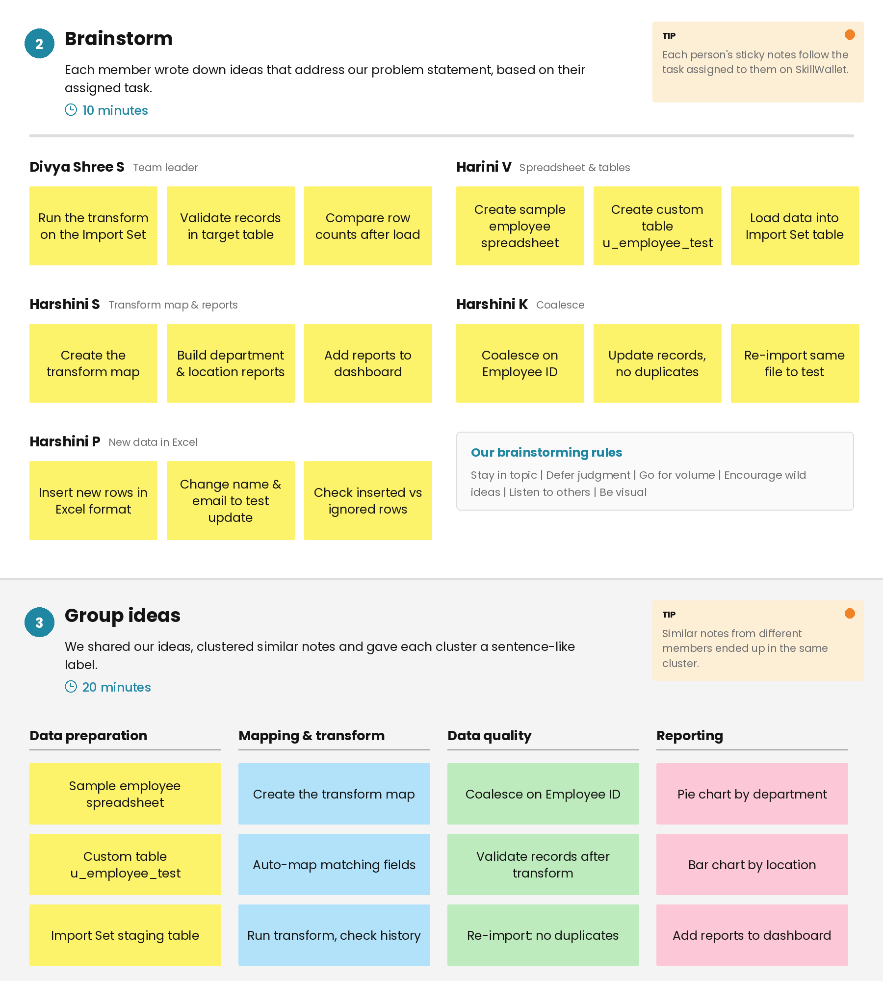  Figure 1: Brainstorm ideas grouped by theme | 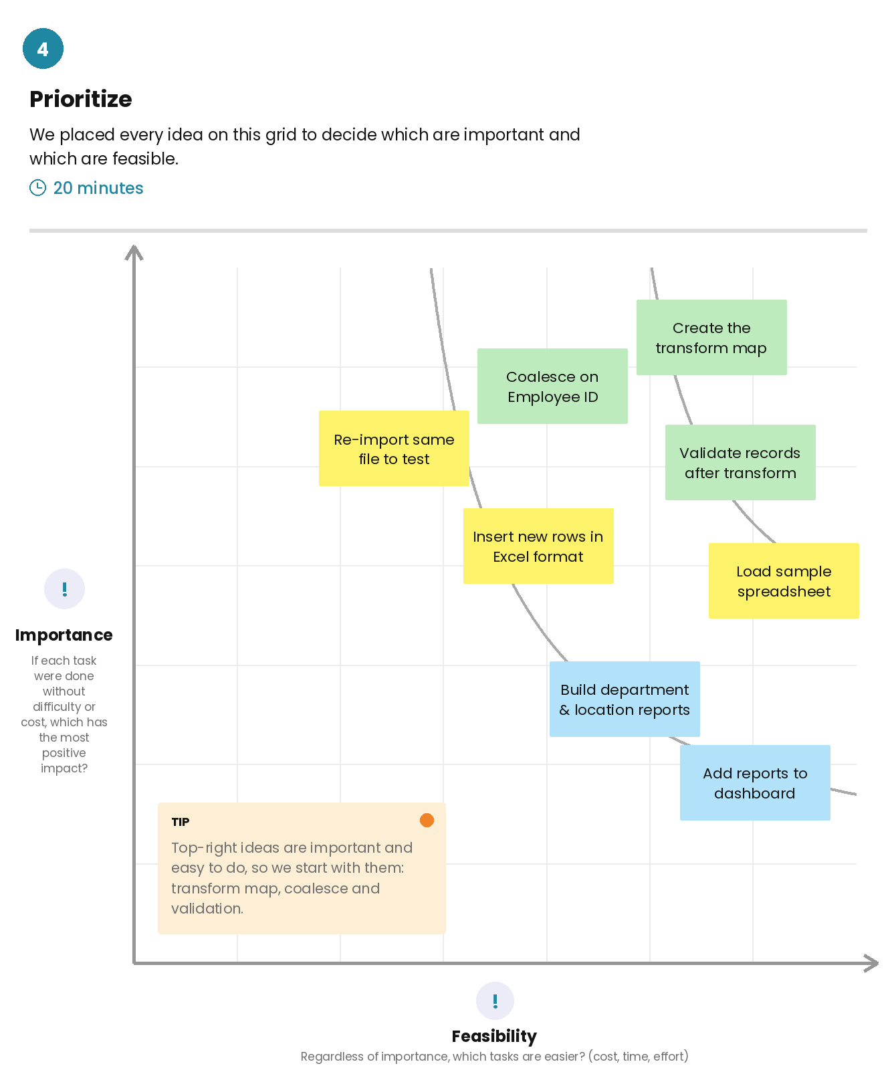  Figure 2: Idea prioritization grid

3. Requirement Analysis

3.1 Customer Journey Map
The journey map follows the data administrator through five stages while importing, validating and reporting on employee data from an Excel spreadsheet in ServiceNow.
Stage | Steps | Positive moments | Pain points
1. Entice | Receive the Excel sheet, review the data, plan the import (decide which field identifies an employee). | Sheet arrives with all new and updated employees. | Sheets often have blank cells or typos. Not sure which field is unique for an employee.
2. Enter | Create the Employee Test table, add its fields, load the Excel file with Load Data, create the Import Set table. | Load Data makes uploading simple and a success message appears after submitting. | Each field has to be added one by one. A wrong sheet number or header row causes errors.
3. Engage | Create the Transform Map, map the fields with Auto Map and Mapping Assist, enable Coalesce, run the transform. | Auto Map matches most fields instantly, Coalesce updates records automatically and the transform completes with a Success state. | It is easy to map a wrong column. Without Coalesce, duplicate records are created.
4. Exit | Check the Transform History, validate the records, re-import the same sheet to test. | Clear counts of inserted, updated and ignored rows. A repeat import inserts 0 new rows. | Columns must be rearranged to read the data. Old duplicates have to be removed by hand.
5. Extend | Create the reports, add them to a dashboard, reuse the Transform Map for new files. | Charts make the data easy to understand. The saved Transform Map can be reused. | Duplicates inflate the report counts.

3.2 Solution Requirements
Functional requirements
FR No. | Functional Requirement (Epic) | Sub Requirement (Story / Sub-Task)
FR-1 | Table & Data Setup | Create the custom Employee Test table (u_employee_test).  Add the fields Employee ID, Employee Name, Email, Department and Location.  Prepare the Excel sheet with a header row.
FR-2 | Data Import | Upload the Excel file using System Import Sets > Load Data.  Create the Import Set (staging) table Employee Import (u_employee_import).  Check the loaded rows in the staging table.
FR-3 | Transform & Field Mapping | Create the Transform Map “Sample Spreadsheet Import” from the Import Set table to Employee Test.  Map source fields to target fields using Auto Map Matching Fields and Mapping Assist.  Run the transform and check the Transform History.
FR-4 | Duplicate Prevention | Enable Coalesce on Employee ID to update existing employees.  Re-import the same sheet to confirm that no duplicates are created.
FR-5 | Data Validation | Validate the imported records in the Employee Test table.  Check that all columns show correctly in the list view (Personalize List Columns).
FR-6 | Reporting & Dashboard | Create a pie chart of employees by department.  Create a bar chart of employees by location.  Create an Employee List Report.  Add the saved reports to the Employee Analytics Dashboards dashboard.
FR-7 | Access Control (Roles & ACL) | Planned: create a role and ACLs for read and write access to the Employee Test table. This requirement is not covered in the UAT of this release.
Non-functional requirements
NFR No. | Non-Functional Requirement | Description
NFR-1 | Usability | The administrator imports data using standard ServiceNow modules (Load Data and Transform Maps). Auto Map matches most fields instantly and a saved Transform Map can be reused for new files.
NFR-2 | Security | Access to the Employee Test table can be controlled with a role and ACLs so only authorised users can read and write records (planned, not covered in this UAT).
NFR-3 | Reliability | Coalesce on Employee ID updates existing records instead of creating duplicates, and the Transform History shows the inserted, updated and ignored row counts for every import.
NFR-4 | Performance | A spreadsheet loads into the staging table and transforms into the Employee Test table within seconds, and a success message confirms completion.
NFR-5 | Availability | The import, reports and dashboard are available whenever the ServiceNow instance is running, and the data is stored in ServiceNow tables.
NFR-6 | Scalability | The same Transform Map can be reused for new spreadsheets, more fields can be added to the table, and imports can later be scheduled instead of run by hand.

3.3 Data Flow Diagram
A data flow diagram shows how data enters and leaves the system, what changes it and where it is stored. The Level 0 flow of this project is shown in the figure in section 4.3 and is explained below.
Simplified flow
- The sales, HR or support team sends the employee data (new and updated employees) as an Excel sheet to the data administrator.
- The administrator reviews the sheet for blanks, typos and duplicate Employee IDs, then creates the Employee Test table and its fields in ServiceNow.
- The administrator uploads the Excel file using System Import Sets > Load Data, which loads the rows into the Import Set (staging) table.
- A Transform Map maps the source fields to the target fields, with Coalesce enabled on Employee ID.
- The transform runs: new employees are inserted, existing employees are updated, and the Transform History records the counts.
- The administrator validates the data in the Employee Test table, and the viewer opens the reports and dashboard (pie chart by department, bar chart by location, employee list).
Elements of the Level 0 diagram
Element | Description
External entities | Data source (Excel / Google Sheet), data administrator, dashboard viewer
Processes | 1 Load Data (Import Set), 2 Transform and Map (Coalesce on Employee ID), 3 Reports and Dashboard
Data stores | Import Set table Employee Import (u_employee_import), Transform History, Employee Test table (u_employee_test)
Data flows | Excel file, staged rows, source rows, transform counts, inserted/updated records, employee records read by the reports

3.4 Technology Stack
Table 1: Components and technologies
S.No | Component | Description | Technology
1 | User Interface | How the administrator and viewer interact with the application (Load Data page, list and form views, reports and dashboard) | ServiceNow web UI in a browser
2 | Application Logic-1 | Loads the Excel file into the Import Set (staging) table | ServiceNow Import Sets (System Import Sets > Load Data)
3 | Application Logic-2 | Maps source fields to target fields and updates existing employees using Coalesce on Employee ID | ServiceNow Transform Maps, Auto Map Matching Fields, Mapping Assist
4 | Application Logic-3 | Builds the pie chart by department, the bar chart by location, the list report and the dashboard | ServiceNow Reports and Dashboards
5 | Database | Custom Employee Test table with its fields, and the Import Set staging table | ServiceNow tables (Employee Test, Employee Import)
6 | Cloud Database | Database service on the cloud that stores the imported employee data | ServiceNow instance database (Personal Developer Instance)
7 | File Storage | Source employee data file (.xlsx) prepared and uploaded from the local computer | Google Sheets / Microsoft Excel, local file system
8 | External API | No external API is used; data is loaded by manual file upload | Not applicable
9 | Machine Learning Model | Not used in this project | Not applicable
10 | Infrastructure (Server / Cloud) | Application hosted on the cloud. No local server configuration is needed; the instance is accessed through a browser | ServiceNow-hosted Personal Developer Instance
Table 2: Application characteristics
S.No | Characteristic | Description | Technology
1 | Open-Source Frameworks | No open-source framework is used; the solution is built with built-in ServiceNow platform features | Import Sets, Transform Maps, Reports
2 | Security Implementations | Access to the instance is through an administrator login. A role and ACLs for the Employee Test table are planned | ServiceNow Roles and ACLs
3 | Scalable Architecture | The same Transform Map is reused for new spreadsheets, more fields can be added, and imports can later be scheduled | Import Sets, Transform Maps, Scheduled Imports
4 | Availability | Runs on the ServiceNow cloud instance and is available whenever the instance is running | ServiceNow cloud instance (PDI)
5 | Performance | Rows are loaded in bulk into a staging table, the transform runs within seconds and the Transform History shows the counts | Import Set staging table, Coalesce field, Transform History

4. Project Design

4.1 Problem Solution Fit
Problem-solution fit means that the problem found with the user is the one the solution actually solves. The canvas for this project is summarised below.
Canvas element | Description
Customer segment | Data administrators who import bulk employee data from Excel into ServiceNow, managers and HR who view employee reports, and team members who send the Excel sheets.
Jobs-to-be-done / problems | Import employee data without missing rows, update existing employees instead of creating duplicates, avoid mapping the wrong column, and keep reports accurate and easy to trust.
Triggers | A new Excel sheet of new and updated employees arrives, report counts look inflated, or duplicate or outdated details are noticed.
Emotions | Before: frustrated and worried about data accuracy. After: confident, in control and trusting the data.
Available solutions | Adding employees one by one on the form (slow, error-prone), importing without a coalesce field (creates duplicates), and removing duplicates by hand.
Problem root cause | Data arrives as spreadsheets, and the transform map has no coalesce field (Employee ID), so every repeated import inserts the same employees again.
Behaviour | Check the sheet, create the table and fields, upload with Load Data, create the Transform Map, run the transform, check the Transform History, validate the records and re-import to confirm no duplicates.
Channels | Online: email or team chat to receive the file, Google Sheets or Excel to prepare data, and ServiceNow (Load Data, Transform Maps, Transform History, Reports, Dashboard). Offline: talking with the team to confirm which field identifies an employee.
Our solution | Import with an Import Set and a Transform Map, enable Coalesce on Employee ID, validate the result and show clean data in reports on a dashboard.

4.2 Proposed Solution
S.No | Parameter | Description
1 | Problem statement | Administrators import bulk employee data from Excel into ServiceNow, but without a coalesce field such as Employee ID the transform creates duplicate records and does not update old details, so report counts look inflated and cannot be trusted.
2 | Idea / solution description | Load the Excel file into a staging table, map the fields with Auto Map and Mapping Assist, and enable Coalesce on Employee ID so existing employees are updated instead of duplicated. Check the Transform History and the Employee Test table, then show the clean data in reports on a dashboard.
3 | Novelty / uniqueness | Uses only built-in ServiceNow features with no extra code or tools. Coalesce updates existing records instead of adding duplicates, a saved Transform Map can be reused, and a re-import test proves that no duplicates are created.
4 | Social impact / satisfaction | Administrators save time and avoid cleaning duplicates by hand, and managers can trust the reports built on accurate employee data.
5 | Business model | An internal efficiency tool on the organisation’s existing ServiceNow platform. The benefit comes from saved administrator time and fewer data errors, and it can be packaged as a reusable import template for other teams.
6 | Scalability | The same Transform Map can be reused for new spreadsheets, more fields can be added, imports can be scheduled, and the approach can be extended to other tables and teams on the ServiceNow cloud platform.

4.3 Solution Architecture
Solution architecture bridges the gap between the business problem and the technology solution. The figure shows the layers of the solution and how data moves through them.
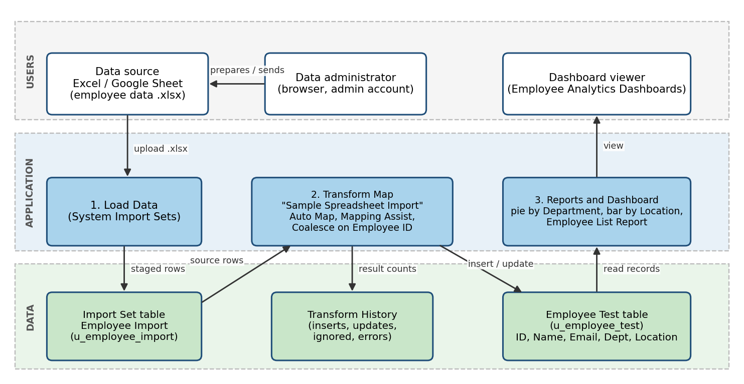
Figure 3: Architecture and data flow for importing employee data from Excel into ServiceNow
Data flow: (1) the administrator prepares the Excel sheet, (2) uploads it with Load Data, (3) the rows are saved in the Import Set staging table, (4) the Transform Map reads the staged rows and maps the fields, (5) the transform result is logged in the Transform History, (6) inserted and updated records are stored in the Employee Test table using Coalesce on Employee ID, and (7) the reports read the Employee Test table and are shown on the dashboard.

5. Project Planning & Scheduling

5.1 Project Planning
The work was planned in three sprints of six days each. The planned scope is 36 story points across 16 user stories.
Sprint | Epic | USN | User story / task | Points | Priority | Team member
Sprint-1 | Table & Data Setup | USN-1 | Create the Employee Test custom table | 2 | High | Harini V
 |  | USN-2 | Add the employee fields with the right types | 2 | High | Harini V
 |  | USN-3 | Prepare an Excel sheet with a header row that matches the table fields | 3 | High | Harini V
 | Import Data | USN-4 | Upload the Excel file using System Import Sets > Load Data | 1 | High | Harini V
 |  | USN-5 | Open the staging table and check the loaded rows | 1 | Medium | Harini V
 | Data Submission | USN-11 | Send the latest employee data in an Excel sheet to the administrator | 1 | Medium | Harshini P
Sprint-2 | Transform & Mapping | USN-6 | Create a Transform Map from the Import Set table to the Employee Test table | 2 | High | Harshini S
 |  | USN-7 | Map source fields to target fields using Auto Map Matching Fields and Mapping Assist | 3 | High | Harshini S
 |  | USN-8 | Run the transform and check the Transform History | 2 | High | Divya Shree S
 | Duplicate Prevention | USN-9 | Enable Coalesce on Employee ID so existing employees are updated instead of duplicated | 5 | High | Harshini K
Sprint-3 | Validation | USN-10 | Validate the imported records in the Employee Test table | 3 | Medium | Divya Shree S
 | Reporting | USN-12 | Create a pie chart of employees by department | 2 | Medium | Harshini S
 |  | USN-13 | Create a bar chart of employees by location | 2 | Medium | Harshini S
 |  | USN-14 | Show the saved reports together on a dashboard | 2 | Low | Harshini S
 | Security (Roles & ACL) | USN-15 | Create a role and assign it to a user | 2 | Medium | Divya Shree S
 |  | USN-16 | Create ACLs that give read and write access to the table only to that role | 3 | Medium | Divya Shree S
USN-15 and USN-16 (Roles & ACL) were planned in Sprint-3 but are not covered in the UAT of this release.
Sprint schedule
Sprint | Total story points | Duration | Sprint start date | Sprint end date (planned) | Cumulative points
Sprint-1 | 10 | 6 days | 29 Sep 2026 | 04 Oct 2026 | 10
Sprint-2 | 12 | 6 days | 05 Oct 2026 | 10 Oct 2026 | 22
Sprint-3 | 14 | 6 days | 12 Oct 2026 | 17 Oct 2026 | 36
Velocity: The sprint duration is 6 days and the team velocity is 36 story points / 3 sprints = 12 story points per sprint. The average velocity per day is 12 / 6 = 2 story points per day.
Burndown chart
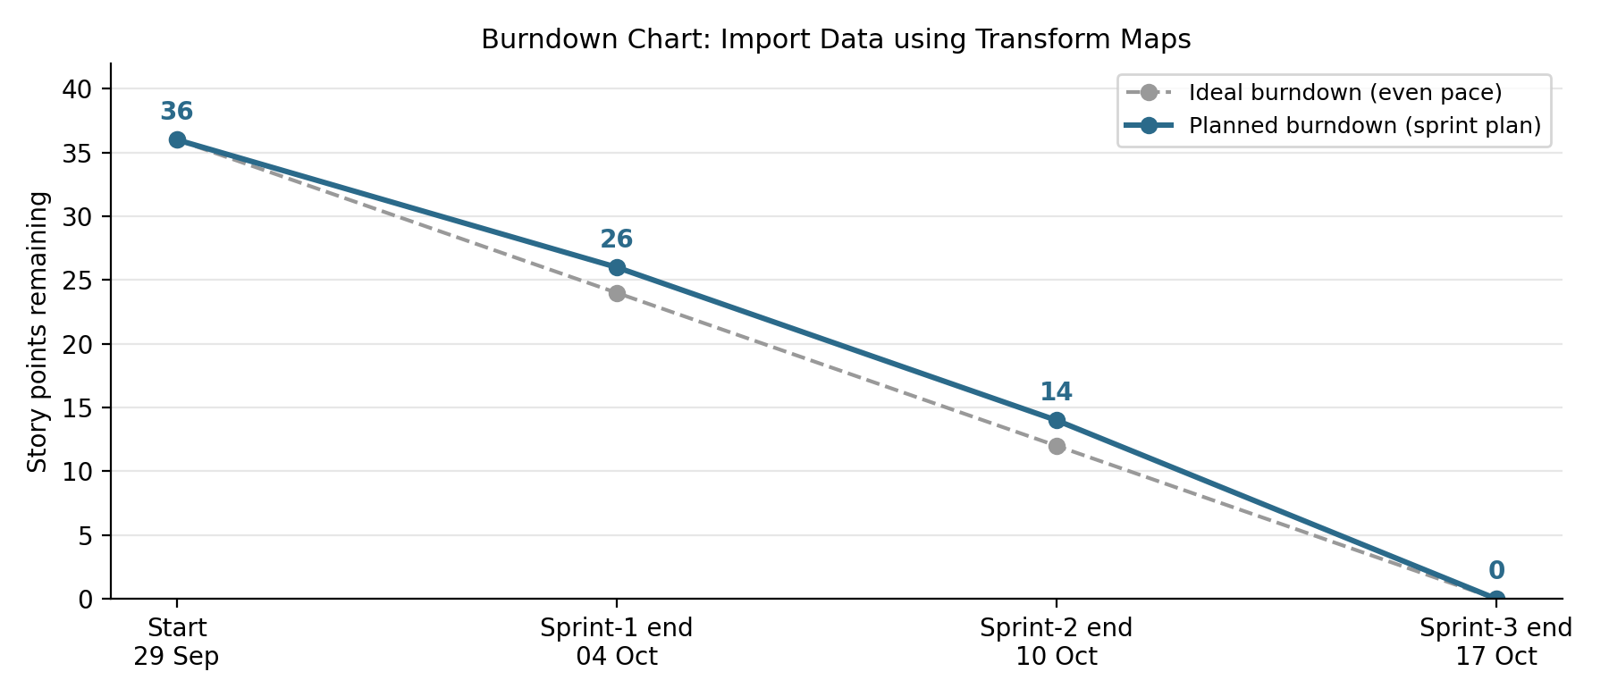
Figure 4: Planned burndown of 36 story points across three sprints

6. Functional and Performance Testing

6.1 Performance Testing
Performance was checked on the import itself: whether the data loaded and transformed correctly, whether the records were validated, and whether repeated imports avoided duplicates.
S.No | Parameter | Values
1 | Model summary | ServiceNow data import setup for employee data using an Import Set (Employee Import, u_employee_import), a Transform Map (Sample Spreadsheet Import) and the Employee Test table. Five fields are mapped: u_employee_id, u_name, u_email, u_department and u_location map to the matching Employee Test fields (5 of 5 mapped).
2 | Accuracy (import accuracy) | Load Data (ImportProcessor): State Complete, Completion code Success. Processed 5, Inserts 5, Updates 0, Errors 0, Empty and ignored 0. Transform (ISET0010002): State Complete, Completion code Success, Transformation complete. Import accuracy 100% (5 of 5 rows imported with 0 errors).
3 | Data validation | The Employee Test table showed all 5 records (1 to 5 of 5) with Employee ID, Employee Name, Department, Email and Location. After the next import with a new row (SB0006) it showed 6 records, and SB0001 to SB0005 each appeared only once, so no duplicates were created.
4 | Duplicate check (re-import) | With Coalesce set to true on Employee ID, the same sheet was imported again. The Transform History showed Total 4, Inserts 0, Updates 0, Ignored 4, Errors 0.
User acceptance test results
Test case | Scenario | Actual result | Result
TC-001 | Create the Employee Test table with its fields | Form shows Employee ID, Employee Name, Email, Department and Location | Pass
TC-002 | Upload the Excel file using Load Data | Complete / Success. Processed 5, inserts 5, updates 0, errors 0 | Pass
TC-003 | Create the Transform Map and map the fields | 5 field maps created from the staging fields to the Employee Test fields | Pass
TC-004 | Run the transform | Complete / Success, Transformation complete | Pass
TC-005 | Validate the imported records | All 5 records shown in the list view (1 to 5 of 5) | Pass
TC-006 | Import an updated sheet with a new employee | Table shows 6 records; SB0006 added, SB0001 to SB0005 appear once each | Pass
TC-007 | Re-import the same sheet (duplicate check) | Total 4, Inserts 0, Updates 0, Ignored 4, Errors 0 | Pass
TC-008 | Employees by Department pie chart | ServiceNow 11, Salesforce 4, Aiml 2 (17 employees) | Pass
TC-009 | Employees by Location bar chart | Hyderabad 16, Chennai 1 (17 employees) | Pass
TC-010 | Employee List Report | 1 to 17 of 17 records with all five columns | Pass
TC-011 | Add the reports to the dashboard | All three reports appear on the Employee Analytics Dashboard | Pass
All 11 test cases passed (0 failed, 0 not tested) and no defects were recorded. Access Control (Roles & ACL) is not covered in this UAT.

7. Results

7.1 Output Screenshots
Data preparation
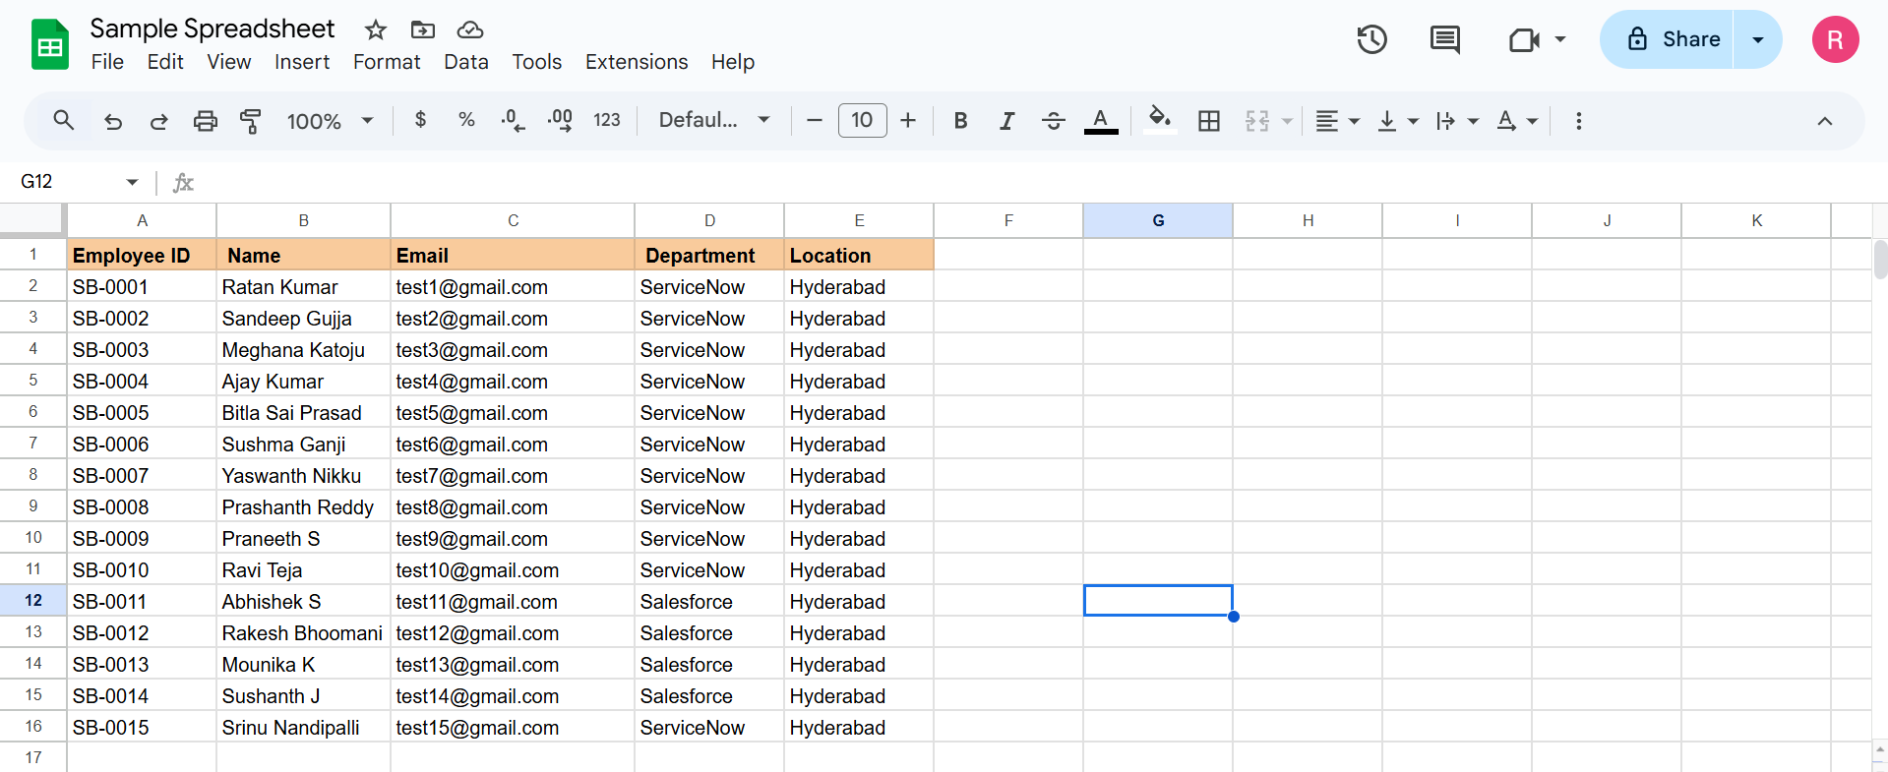
Figure 5: Sample spreadsheet with employee data
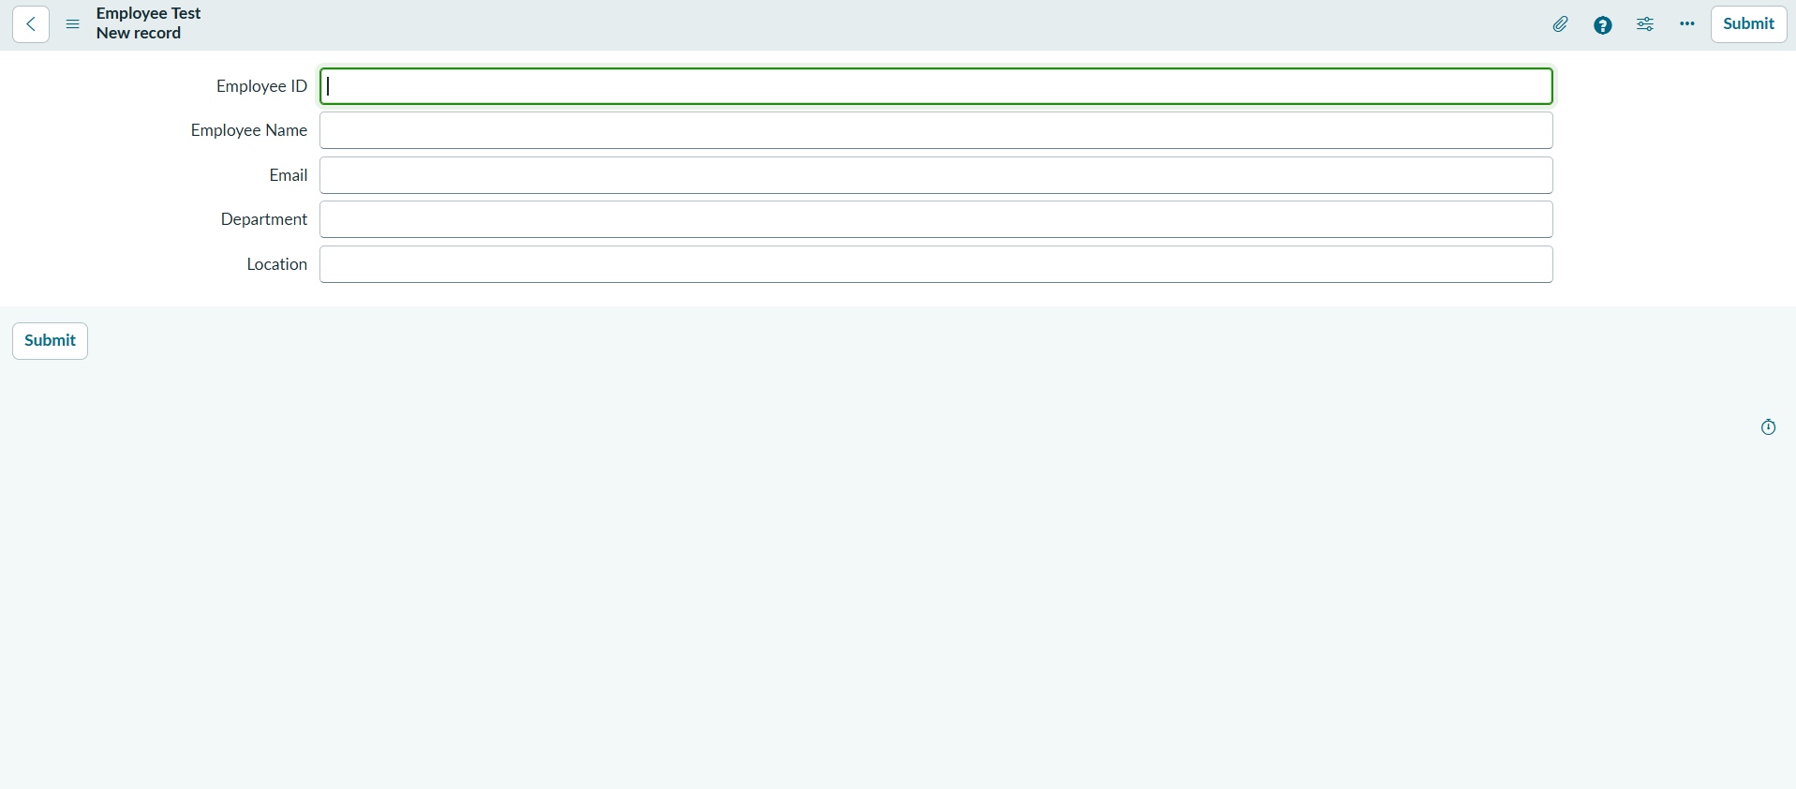
Figure 6: Employee Test form with the five fields
Import and transform
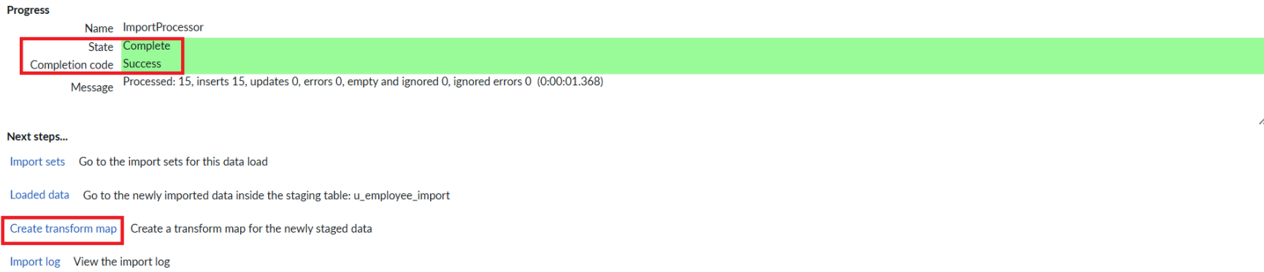
Figure 7: Load Data completed with Success
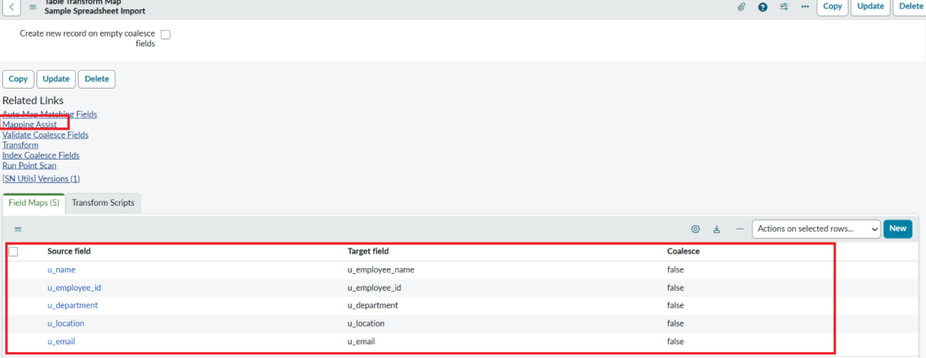
Figure 8: Transform Map field maps (source field to target field)
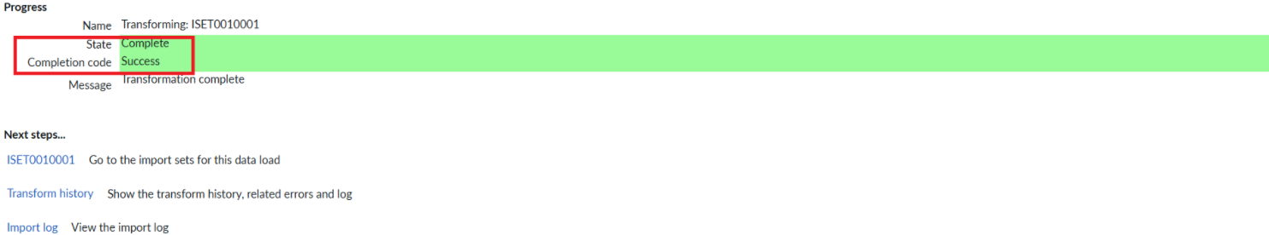
Figure 9: Transform completed with Success
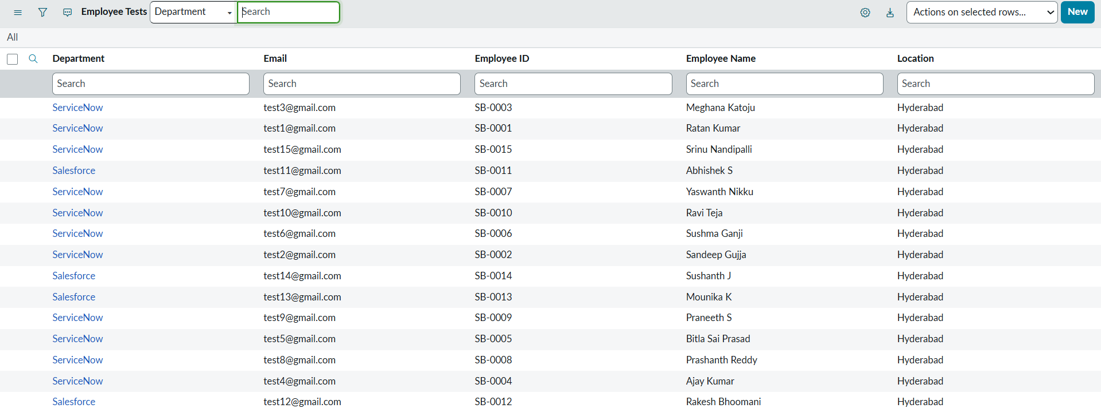
Figure 10: Imported records in the Employee Test table
Duplicate prevention
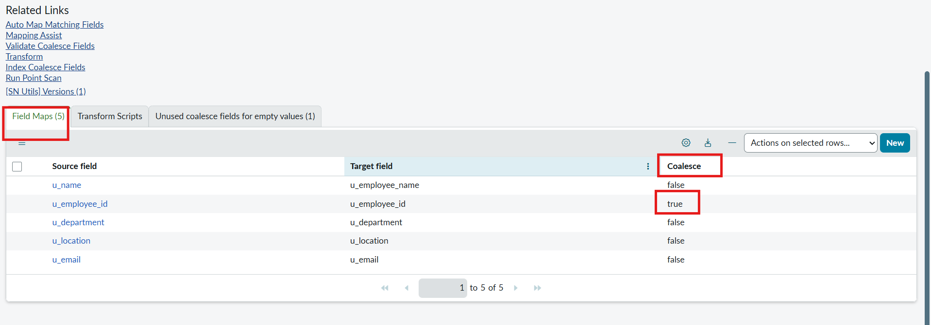
Figure 11: Coalesce set to true on Employee ID
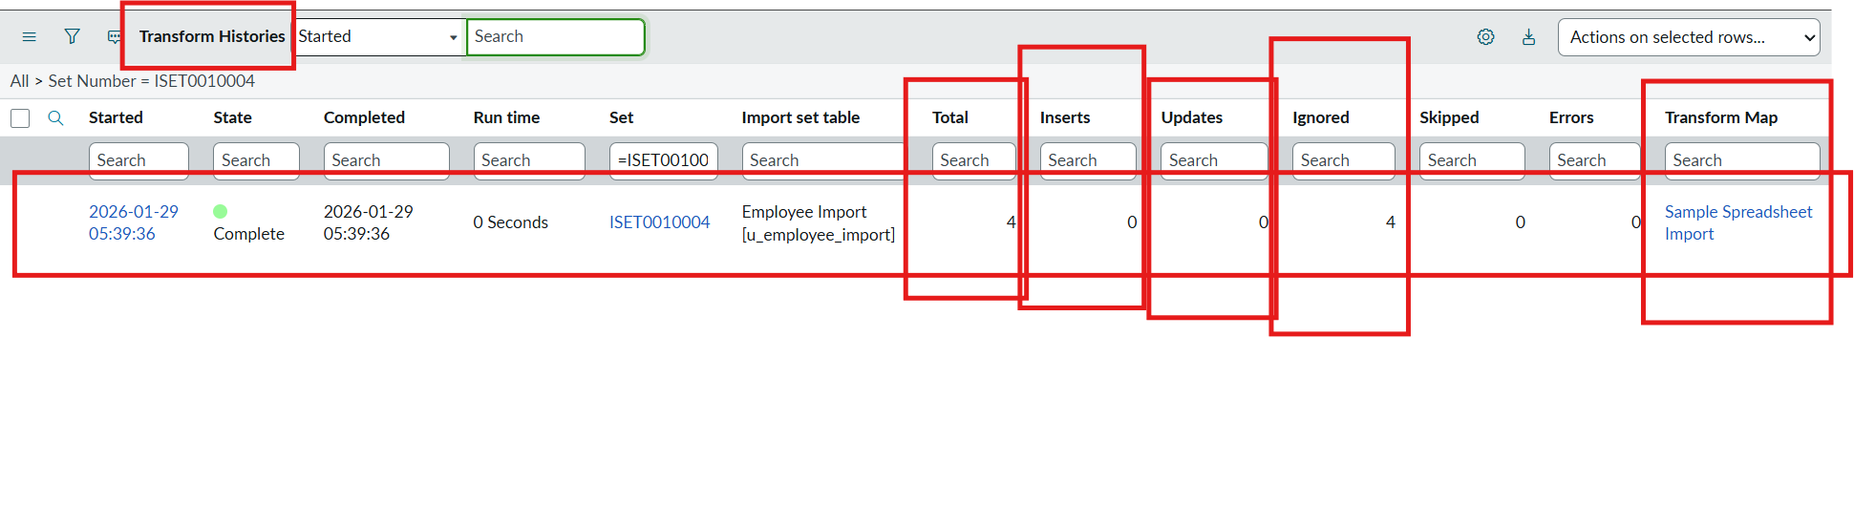
Figure 12: Transform History of the re-import: 0 inserts, 0 updates, 4 ignored
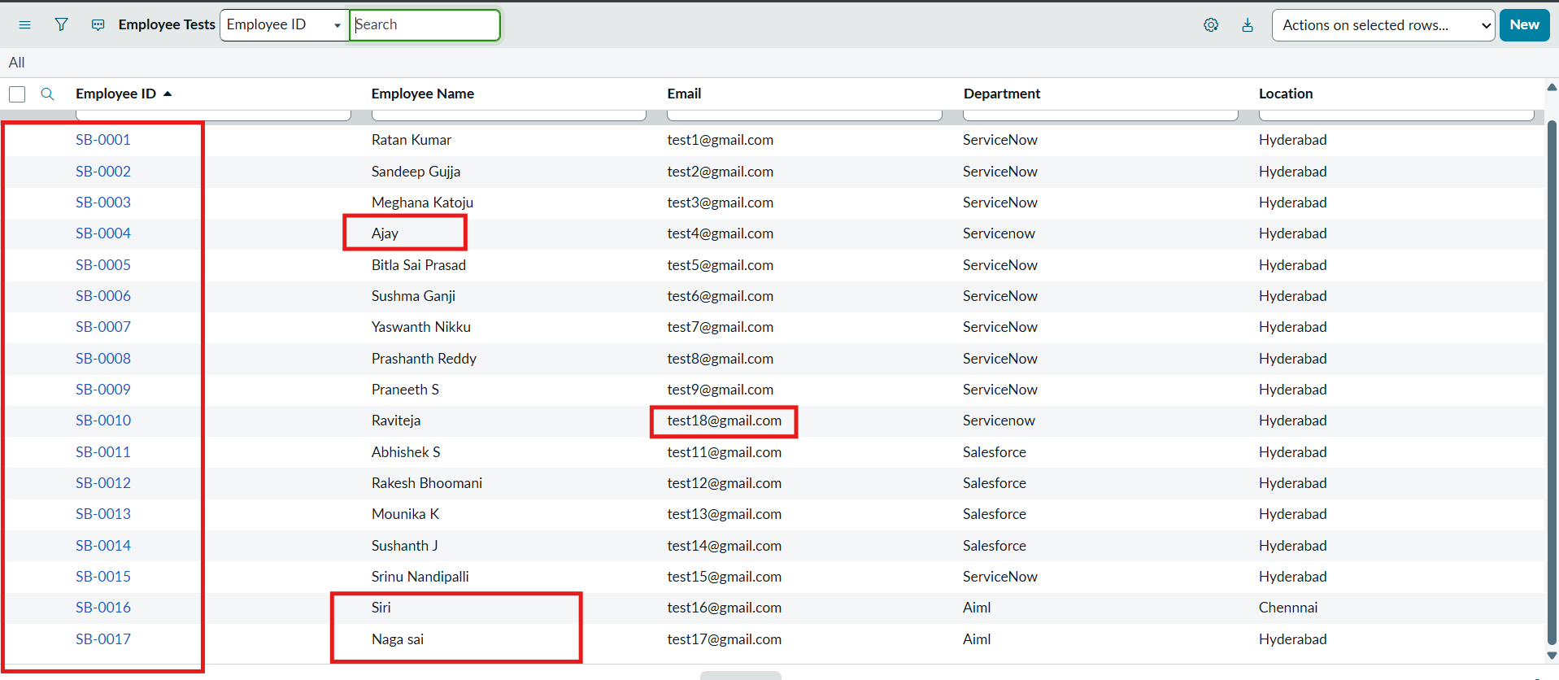
Figure 13: Employee Test table after importing updated and new employees
Reports and dashboard
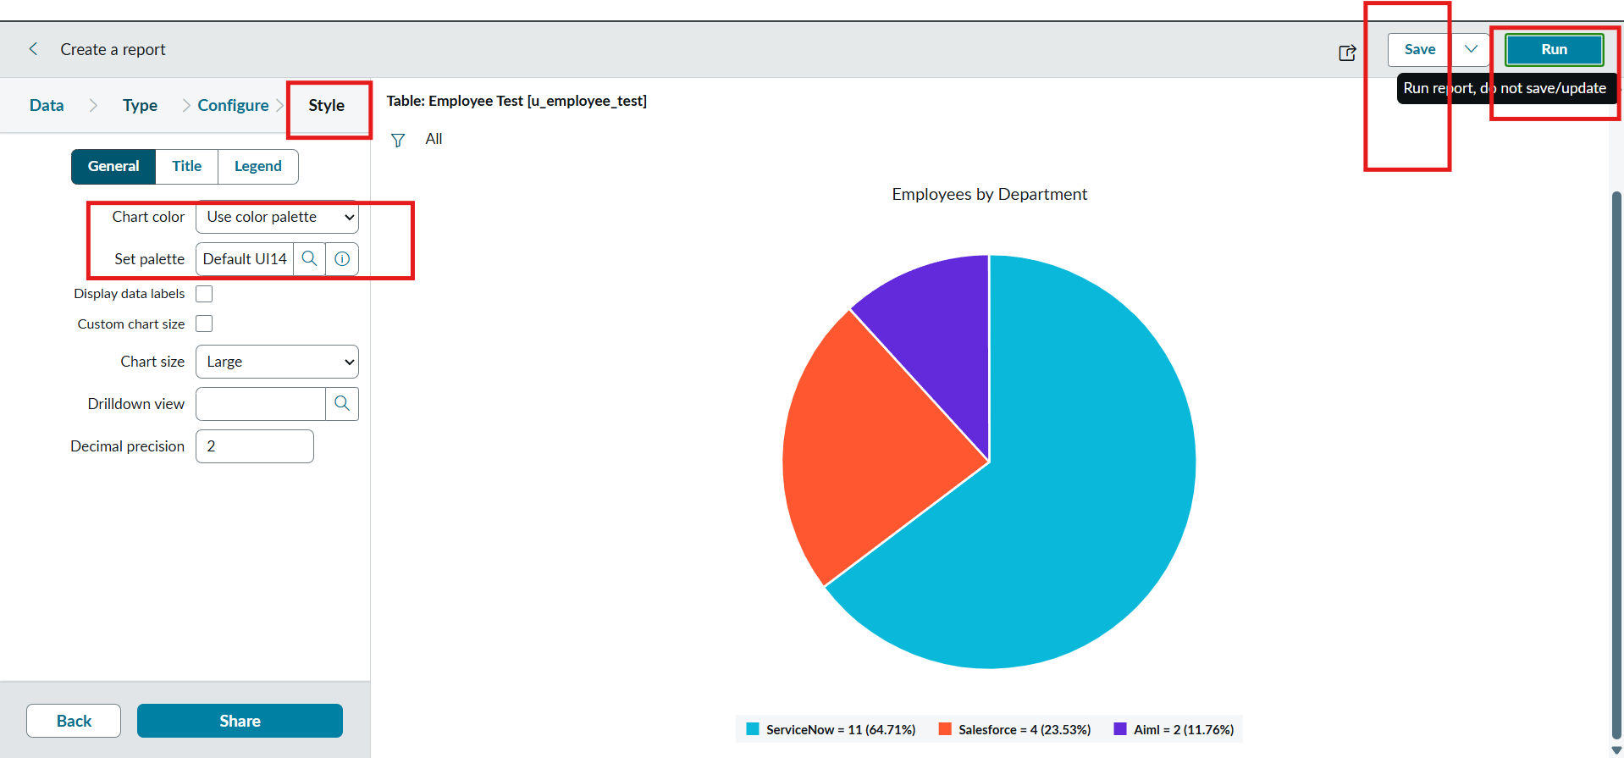
Figure 14: Employees by Department pie chart
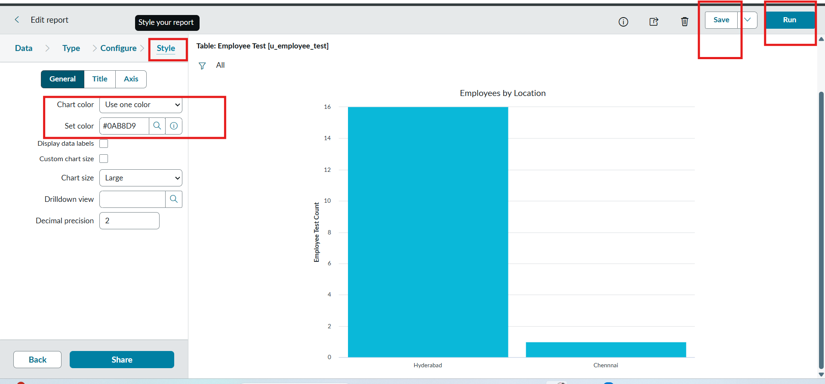
Figure 15: Employees by Location bar chart
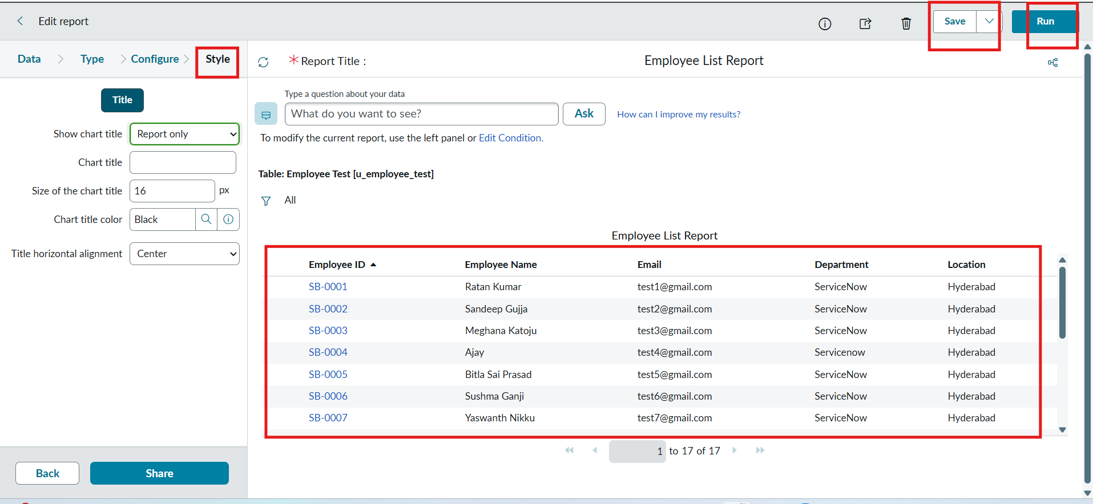
Figure 16: Employee List Report
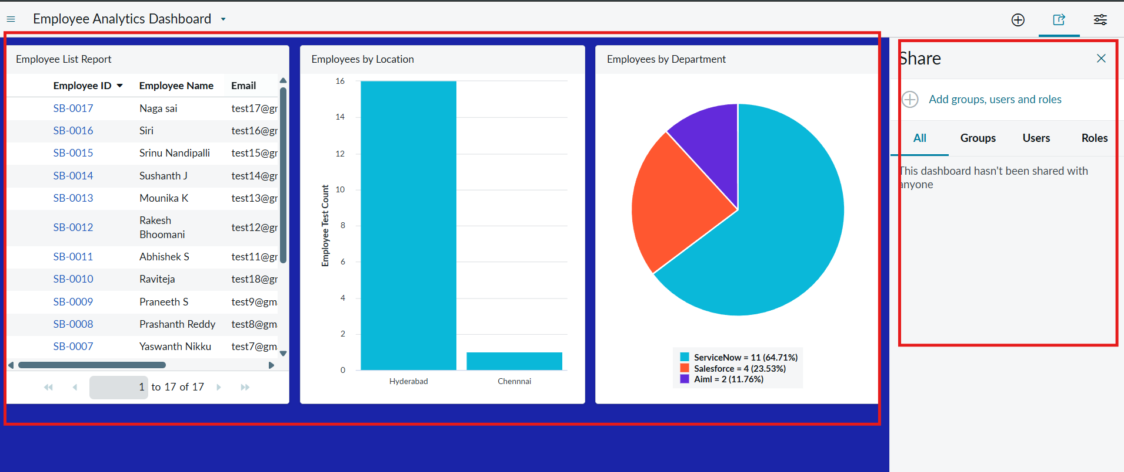
Figure 17: Employee Analytics Dashboard with the three reports

8. Advantages & Disadvantages
Advantages
- Built-in features only: no custom code or extra tools are needed, only Import Sets, Transform Maps, Reports and Dashboards.
- No duplicate records: Coalesce on Employee ID updates existing employees, and the re-import test (0 inserts, 0 updates, 4 ignored) proves it.
- Fast and accurate import: rows load in bulk into a staging table and the transform runs within seconds, with the Transform History showing the exact counts.
- Reusable: a saved Transform Map can be run again for new spreadsheets with the same columns.
- Reliable reporting: the reports and dashboard are built on clean data, so the counts can be trusted.
- Easy to learn: the step-by-step process suits beginners learning data import in ServiceNow.
Disadvantages
- Manual upload: the file is uploaded by hand each time; imports are not yet scheduled.
- Depends on clean sheets: a missing header row, wrong sheet number or blank cells can cause errors or wrong mapping.
- Needs a unique key: Coalesce works only if each employee has a unique Employee ID in the sheet.
- Access control not covered: the role and ACLs for the Employee Test table are planned but were not part of this UAT.
- Small sample data: the project was tested on a small sample dataset on a developer instance, not on production-scale data.

9. Conclusion
The project successfully imported employee data from a spreadsheet into ServiceNow using an Import Set and a Transform Map. The data was loaded into a staging table, mapped to the Employee Test table, transformed with a Success state and validated in the list view.
A key improvement was the use of Coalesce on the Employee ID field. When the same sheet was imported again, the Transform History showed 0 inserts and 0 updates with all 4 rows ignored, and importing changed rows updated the existing employees instead of adding duplicates. This keeps the employee table clean, reliable and consistent when data is imported more than once.
The project was extended with three reports (employees by department, employees by location and an employee list) that were brought together on the Employee Analytics Dashboards dashboard. All 11 UAT test cases passed with no defects, which shows that the solution meets its functional goals.

10. Future Scope
- Schedule the import so that new spreadsheets are loaded automatically instead of by hand.
- Add checks for blank cells, typos and duplicate Employee IDs before the file is loaded.
- Create a role and ACLs for the Employee Test table and test access by impersonating users (FR-7).
- Add more fields to the table and the Transform Map, and use transform scripts for clean-up such as trimming spaces or fixing the case of text.
- Reuse the approach for other tables and teams with new Transform Maps.
- Add reports on import activity, such as new, updated and ignored rows for each import, and notifications for failed imports.

11. Appendix
Source Code
No source code was written. The solution is configured with built-in ServiceNow features. The artefacts created on the instance are listed below.
Artefact | Name / details
Target table | Employee Test (u_employee_test): Employee ID, Employee Name, Email, Department, Location
Import Set (staging) table | Employee Import (u_employee_import)
Transform Map | Sample Spreadsheet Import (Employee Import to Employee Test), field maps u_employee_id, u_name, u_email, u_department, u_location, with Coalesce on Employee ID
Reports | Employees by Department (pie chart), Employees by Location (bar chart), Employee List Report (list)
Dashboard | Employee Analytics Dashboards
Dataset Link
Sample Spreadsheet.xlsx (Google Sheet) with the columns Employee ID, Name, Email, Department and Location. After the new and changed rows were imported, the Employee Test table held 17 records.
Link: [add the Google Sheet link here]
GitHub & Project Demo Link
GitHub: [add the GitHub repository link here, if any]
Project demo: [add the demo video link here]

